Deep Knowledge Group Releases Comprehensive
COVID-19 DataBase and MedTech Analytics IT-Platform

New Covid-19 Analytics IT-Platform Aggregates, Categorizes and Visualizes Major MedTech
Activities Across Science, Technology, Treatments, Diagnostics, R&D and Practical Applications
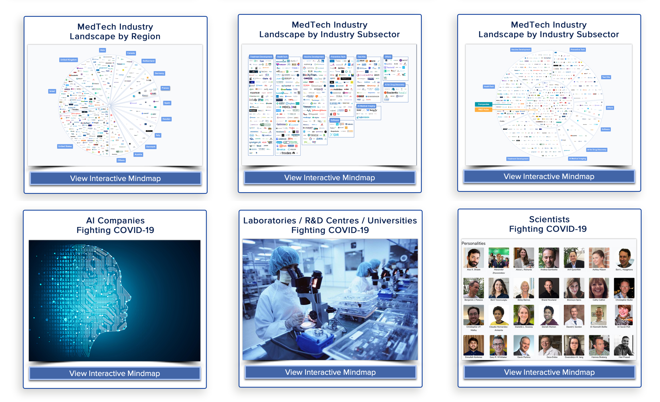

5th of May 2020, Tuesday (10:00am GMT), London, UK - Deep Knowledge Group announced today a major extension of its ongoing COVID-19 Analytics activities through the release of its new COVID-19 MedTech Analytics IT-Platform, designed to serve as a comprehensive database of the most relevant entities, technologies, and developments in the COVID-19 MedTech ecosystem, aggregating, profiling and visualizing the companies, organizations, scientists and technologies at the forefront of neutralizing the COVID-19 pandemic and ensuring the health and safety of individuals and nations during this time of unprecedented crisis. The platform aims to cover all major sectors and relevant activities in the global COVID-19 MedTech landscape from science to technology, R&D, treatment, diagnostic and vaccine development, and practical applications occurring globally, providing data on particular scientific and technological sectors and geographical regions.

Link to COVID-19 MedTech Analytics IT-Platform: www.dkv.global/medtech-covid

The platform was created by Deep Knowledge Analytics utilizing the sophisticated IT-solutions and Interactive MindMap and Data Visualization capabilities that the DeepTech analytics subsidiary of the group has developed over the past several years. Its ultimate aim is to serve a comprehensive database and one-stop informational resource designed to keep both the public and relevant decision makers informed on the latest developments in the COVID-19 MedTech landscape, profiling 95 Treatment Candidates, 85 Vaccine Candidates, 45 Preventative Tech, 40 Test Kits, 240 Scientists, 420 Companies, 535 Investors, 50 Funding Agencies, 1500+ Clinical Trials and 190 Universities, Labs and R&D Hubs working at the frontier of neutralizing the pandemic and promoting beneficial outcomes for those already infected.

The database is in a continuous state of development, and Deep Knowledge Group intends to expand on an ongoing basis its breadth and depth, the scale and scope of its scientific and technological sectors, the number of specific regions it covers, and the overall quantity of entities that it profiles and visualizes.

In the longer term the platform is intended to serve as a distributed knowledge system, crowdsourcing additional data from relevant experts. While Deep Knowledge Group has already aggregated data from multiple reputable public sources and qualified experts within its existing network, we remain open to contributions from experts and specialists interested in expanding the scope and reach of the platform.

In addition to this, the group will also be unveiling enhanced features, including extensive filter and search functions, allowing everybody from the general public to responsible decision makers to use the platform to derive action-based answers and insights to key questions at the heart of national strategic decision making to optimize outcomes in the wake of the current global COVID-19 pandemic.

About Deep Knowledge Group
Deep Knowledge Group is an international consortium of commercial and non-profit organizations focused on the synergetic convergence of DeepTech and Frontier Technologies (AI, Longevity, MedTech, FinTech, GovTech), applying progressive data-driven Invest-Tech solutions with a long-term strategic focus on AI in Healthcare, Longevity and Precision Health, and aiming to achieve positive impact through the support of progressive technologies for the benefit of humanity via scientific research, investment, entrepreneurship, analytics and philanthropy.
About Deep Knowledge Analytics
Deep Knowledge Analytics is a DeepTech focused agency producing advanced analytics on DeepTech and frontier-technology industries using sophisticated multi-dimensional frameworks and algorithmic methods that combine hundreds of specially-designed and specifically-weighted metrics and parameters to deliver sophisticated market intelligence, pragmatic forecasting and tangible industry benchmarking.
For press and media inquiries, please contact media@dkv.global

